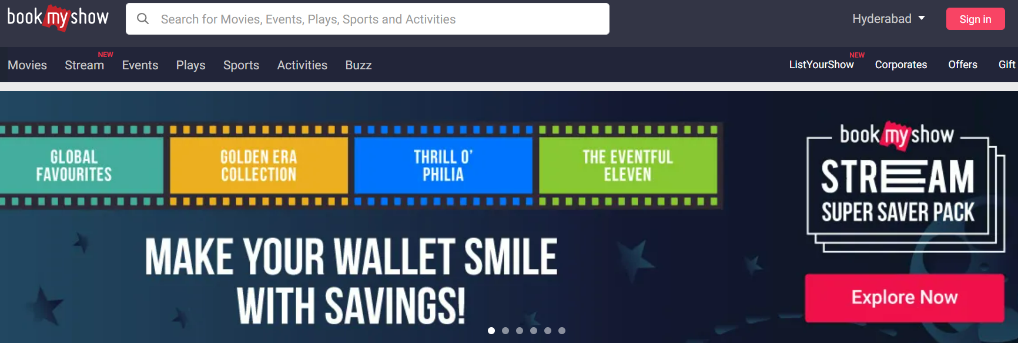

**Overview :**

Bookmyshow is an online Movie or Event ticket website. By selecting the location, language, and timing of the show. The payment mode will be Online

**Main Pages in Flipkart Bookmyshow of**

* Register page,
* Login Page
* Home page
* Ticket Selection
* Payment Gateway

**Sign up Page:**

Sign page is to register the use by providing basic details like Name, Email ID, or Phone number

**Login Page**

The login page will ask us for the credentials to enter the home page.

Login can be an Email ID and Password or a One-time password with a Contact number

**Home Page:**

The home page consists of the

Icon

Menu bar

Search bar

Banners of the New movies or Events

Footer

**Ticket selection page :**

The ticket selection page consists of the Slots or timings with details about the seats to book (movies/Events)

**Payment Gateway**

Payment gateway consists of the methods to select the payment like Online payment (Credit card Debit card or Online Banking)

**Used Technologies**

Frontend : HTML, CSS, JavaScript, React

Backend: NodeJS

Database: MongoDB